**BASE BUILDING ASSIGNMENT**

***ASSIGNMENT QUESTION***

Q1:- **What is difference between UI and UX ?**

**ANS**:- *UX stand for user interface USER EXPERIENCE .* ***The user experience is how a user interacts with and experiences of frontend of any website and webpage ; a product, system or service. It includes a person's perceptions of utility, ease of use, and efficiency. Then a UX DEVLOPER get information requirement of user.***

**UI stand for USER INTERFACE DESIGN .**   
  ***A UI developer specializes in designing and developing the visual and interactive components of websites, web applications, and mobile application according of requirement of user interface.***

***Q2* :- Who is fronted developer ?   
ANS:- *A front-end developer builds the front-end portion of websites and web applications—the part users see and interact with. A front-end developer creates websites and applications using web languages such as HTML, CSS, and JavaScript that allow users to access and interact with the site or app.***

**Q3** :-?**What is backend developer** ?

**ANS*:- Back-end developers are the experts who build and maintain the mechanisms that process data and perform actions on websites.Backend developer skills include : Python, Java, SQL, NoSQL, and Git.***

Q4:- **Screenshots and link of GITHUB AND LINKLEDIN accounts ?**

**ANS:- 

FOR MY LINKEDIN ACCOUNT :- [CLICK HERE](https://www.linkedin.com/messaging/thread/2-MzlkOTlhYzItODNiNy00ZTk1LWI4YTgtMWM2ZGJjMzMzZmIxXzAxMw==/)

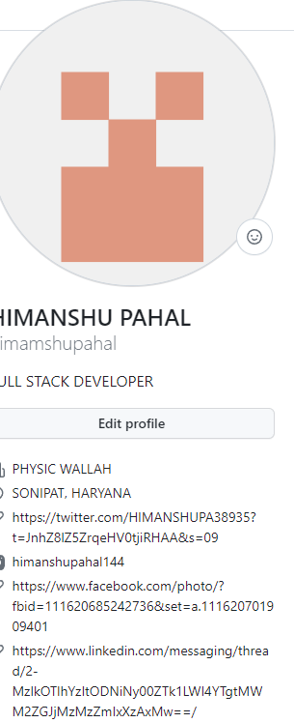

MY GITHUB ACCOUNT :- [CLICK HERE](https://github.com/himamshupahal)

**Q5 Share of link of your first of FIRST BLOG ?  
ANS :- MY FISRT BLOG :-** [**CLICK HERE**](https://himanshu268.hashnode.dev/free-domain)